Project Report
On
eAuto – Bike Spare Parts E-Commerce Platform WFS
In partial fulfillment for the award of the degree Of
BACHELOR OF COMPUTER APPLICATION
[B.C.A]
Year 2025-2026
SUBMITTED BY: | GUIDED BY:
Dhruv Dholiya (4924) | Prof. Bipin Jadhav
Dharmik Dobariya (4928)
Vatsal Kapadia (5029)

BCA-5th SEMESTER
Submitted to:

SHRI SHAMBHUBHAI V. PATEL COLLEGE OF
COMPUTER SCIENCE & BUSINESS
MANAGEMENT
Affiliated to
Veer Narmad South Gujarat University






Acknowledgment

We would like to take this opportunity to express our heartfelt gratitude to everyone who contributed to the successful completion of our project, “eAuto – Bike Spare Parts E-Commerce Platform.”
We are especially grateful to our project guide, Prof. Bipin Jadhav, for her invaluable guidance, continuous encouragement, and insightful feedback throughout the course of this work. Her expert advice and constant motivation have been a source of inspiration and have greatly helped us in achieving our objectives.
We also wish to extend our thanks to all the faculty members of our department for their cooperation, constructive suggestions, and for providing us with the necessary resources and knowledge that supported our project development.
Our sincere appreciation goes to our friends and classmates, whose timely help and support provided us with motivation and confidence during various phases of this project.
Lastly, we would like to acknowledge the dedication, teamwork, and mutual support of our project members, without whom this work would not have been possible:
- Dhruv Dholiya (4924)
- Dharmik Dobariya (4928)
- Vatsal Kapadia (5029)
Together, we have shared valuable experiences that will remain with us beyond the completion of this project.

Index
SR.NO | PARTICULAR | PAGE NO
1 | Introduction
 | 1.1 Background of the Project
 | 1.2 Purpose of the Project
 | 1.3 Scope of the Project
 | 1.4 Objectives
 | 1.5 Advantages of the System
2 | Aim of the Project
 | 2.1 Statement of Aim
 | 2.2 Importance of Aim
 | 2.3 How Aim Solves Current Problems
3 | Features of the Project
 | 3.1 User-side Features
 | 3.1.1 User Registration & Login
 | 3.1.2 Browse & Search Products
 | 3.1.3 Cart & Checkout System
 | 3.1.4 Order Tracking
 | 3.1.5 Profile & Delivery Address Management
 | 3.2 Admin-side Features
 | 3.2.1 Admin Login & Dashboard
 | 3.2.2 Manage Products (Add/Edit/Delete)
 | 3.2.3 Manage Orders
 | 3.2.4 Manage Users
 | 3.2.5 Generate Reports
4 | System Analysis & Design
 | 4.1 Requirement Gathering
 | 4.2 Functional Requirements
 | 4.3 Non-Functional Requirements
 | 4.4 Technology Stack
 | 4.5 Database Design
5. | E-R Diagram
 | 5.1 Entities
 | 5.2 Relationships
 | 5.3 Attributes
 | 5.4 Final ER Model
6. | Data Flow Diagram (DFD)
 | 6.1 Context Level DFD (Level 0)
 | 6.2 Level 1 DFD – User Processes
 | 1.0 Login & Registration
 | 2.0 Product Management
 | 3.0 Cart & Order Management
 | 4.0 Payment Processing
 | 5.0 Supplier & Inventory Management
 | 6.0 Delivery Management
 | 7.0 Reports & Analytics
 | 6.3 Explanation of Data Stores (MongoDB Collections)
7 | Flow Chart
 | 7.1 User Registration & Login Flow
 | 7.2 Product Purchase Flow
 | 7.3 Order Management Flow
 | 7.4 Payment Processing Flow
8 | Implementation Details
 | 8.1 Frontend (React JS, Bootstrap, AOS)
 | 8.2 Backend (PHP – Core PHP for APIs & Logic)
 | 8.3 Database (MongoDB Compass – Collections & Schema)
 | 8.4 Security Features (Authentication, Session Management, Validation)
9 | Testing
 | 9.1 Test Cases (Unit & Integration)
 | 9.2 User Testing (UI/UX & Functional)
 | 9.3 Admin Testing
 | 9.4 Performance & Load Testing
10 | Limitations of the Project
 | 10.1 Technical Limitations (React-PHP integration, MongoDB structure)
 | 10.2 Functional Limitations (Limited Payment Methods, Delivery System)
 | 10.3 Future Enhancements (Mobile App, AI-based Recommendations, Advanced Reports)
11 | Conclusion
 | 11.1 Summary of Work
 | 11.2 Achievements
 | 11.3 Future Scope
12 | References

1. Introduction

1.1 Background of the Project
With the rapid growth of e-commerce, traditional methods of purchasing automobile spare parts are becoming outdated. Customers often face difficulties such as limited availability of parts, lack of price transparency, and difficulty in finding reliable vendors. The eAuto platform aims to address these issues by providing a centralized online marketplace for bike spare parts, offering convenience, affordability, and accessibility.

1.2 Purpose of the Project
The primary purpose of this project is to build an online platform where users can easily browse, compare, and purchase bike spare parts. The system benefits both customers (by offering a wide range of products and hassle-free shopping) and administrators (by providing tools to manage products, users, orders, and deliveries efficiently).

1.3 Scope of the Project
The scope of the eAuto project includes:
- User-side features such as product browsing, cart management, checkout, payment integration, order tracking, and user profile management.
- Admin-side features including product management, user management, order tracking, delivery assignment, and report generation.
- Database integration to maintain records of products, users, orders, and payments.
- Responsive front-end design for mobile and desktop users.

1.4 Objectives
The main objectives of the project are:
- To provide a user-friendly platform for purchasing bike spare parts online.
- To reduce the gap between suppliers and customers through a centralized system.
- To ensure secure payment processing and accurate order tracking.
- To enable administrators to manage inventory, users, and reports efficiently.
- To support future scalability by adding more brands, products, and features.

1.5 Advantages of the System
The proposed system offers several benefits, such as:
- Convenience: Customers can order parts anytime, anywhere.
- Variety: Wide range of spare parts from multiple brands in one place.
- Transparency: Clear product details, pricing, and discounts.
- Efficiency: Faster order processing and delivery management.
- Data-driven: Sales and user data help admins make better business decisions.
- Scalability: System can easily integrate with additional brands, suppliers, or services in the future.

2. Aim of the Project

2.1 Statement of Aim
The aim of the eAuto project is to design and develop a comprehensive online e-commerce platform for bike spare parts that allows users to easily search, compare, and purchase products, while providing administrators with effective tools for managing products, users, orders, and delivery processes.

2.2 Importance of Aim
The importance of this aim lies in addressing the major challenges faced in the traditional spare parts market:
- Accessibility: Customers often struggle to find genuine spare parts at local shops.
- Time Saving: Instead of physically visiting multiple stores, users can buy parts online with just a few clicks.
- Reliability: Ensures quality assurance through verified sellers and transparent pricing.
- Business Growth: Helps suppliers and administrators expand their reach to a larger customer base.
- Technological Advancement: Shifts the spare parts industry toward digital transformation, aligning with modern consumer habits.

2.3 How Aim Solves Current Problems
The aim of this project provides solutions to the existing problems in the bike spare parts domain by:
- Centralized Platform: Eliminates the need for customers to visit multiple vendors by offering all spare parts in one place.
- Real-time Availability: Provides up-to-date stock and pricing information.
- Secure Transactions: Integrates reliable payment gateways to ensure safe purchases.
- Order Tracking: Customers can track the status of their orders and deliveries online.
- Efficient Management: Admin panel allows streamlined management of inventory, users, and reports.
- Customer Satisfaction: Reduces hassle, improves transparency, and enhances the overall buying experience.

3. Features of the Project

3.1 User-side Features

3.1.1 User Registration & Login
- New users can create an account by registering with their email, phone number, and password.
- Existing users can log in using secure authentication.
- Sessions are maintained for user activities like browsing, cart, and checkout.

3.1.2 Browse & Search Products
- Users can browse spare parts based on brand (Hero, Honda, Bajaj, etc.), categories, or price range.
- A search bar enables quick product lookup by name or part number.
- Product details such as image, description, price, discounts, and availability are displayed.

3.1.3 Cart & Checkout System
- Users can add multiple products to their shopping cart.
- Cart preview is available in the header for easy access.
- Checkout includes selection of delivery address, payment method (Cash, Card, UPI, NetBanking), and order confirmation.
3.1.4 Order Tracking
- Customers can view their order history and the current status (Pending, Processed, Shipped, Delivered).
- Real-time updates ensure transparency in the delivery process.

3.1.5 Profile & Delivery Address Management
- Users can manage their personal details, password, and contact information.
- Multiple delivery addresses can be added, edited, or deleted for convenience.

3.2 Admin-side Features

3.2.1 Admin Login & Dashboard
- Secure admin login with authentication.
- Dashboard displays key statistics like total users, orders, sales, and product inventory status.

3.2.2 Manage Products (Add/Edit/Delete)
- Admins can add new products with details like name, brand, price, discount, stock quantity, and image.
- Existing products can be edited or updated.
- Outdated or unavailable products can be deleted from the system.

3.2.3 Manage Orders
- Admins can view all orders placed by users.
- Orders can be updated with statuses such as Pending, Approved, Shipped, Delivered, or Cancelled.
- Delivery staff can be assigned to orders for timely dispatch.

3.2.4 Manage Users
- Admins can view and manage registered users.
- Option to block or remove users in case of fraudulent activity.
- User data (profile, order history) can be accessed for support purposes.

3.2.5 Generate Reports
- Reports can be generated for sales, revenue, product performance, and customer activity.
- Helps administrators analyze business growth and make data-driven decisions.

4. System Analysis & Design

4.1 Requirement Gathering
Requirement gathering is done by analyzing the needs of customers and administrators. Sources include surveys, existing system analysis, and direct feedback.
- User Requirements:
  - Easy product browsing and searching.
  - Secure login and profile management.
  - Cart, checkout, and payment options.
  - Order tracking and history.
- Admin Requirements:
  - Ability to manage products, users, and orders.
  - Generate reports for sales and performance.
  - Dashboard for real-time insights.

4.2 Functional Requirements
Functional requirements describe what the system should do:
- User-side
  - Register/Login/Logout functionality.
  - Browse products by category/brand.
  - Search products with filters.
  - Add to cart, view cart, and checkout.
  - Manage profile and delivery address.
  - Track orders and view history.
- Admin-side
  - Secure login for admins.
  - Manage product details (add, update, delete).
  - Manage users and their activities.
  - Manage orders (status updates, assign delivery).
  - Generate sales and inventory reports.

4.3 Non-Functional Requirements
These define system qualities rather than features:
- Performance: Fast loading times, responsive design, optimized queries.
- Scalability: Support for future expansion with more users and products.
- Security: Encrypted passwords, secure payment gateway, session management.
- Usability: Simple and intuitive UI for both users and admins.
- Availability: High uptime with reliable hosting.
- Maintainability: Clean code structure, modular design, and easy updates.

4.4 Technology Stack

Front-End
- React.js → Component-based architecture for building dynamic and reusable UI.
- HTML5 → Structure of web pages.
- CSS3 → Styling, animations, and responsive layouts.
- JavaScript (ES6+) → Client-side interactivity and logic.
- Bootstrap 5 → Predefined responsive UI components.
- AOS (Animate On Scroll) → Smooth scroll-based animations.
- PHP (for legacy UI/session handling) → Used for rendering certain UI components and managing sessions (in earlier implementation).

Back-End
- Option 1 (Earlier Stack – PHP)
  - Core PHP → Server-side scripting and session handling.
  - XAMPP (Apache + PHP + MySQL) → Local development server.
- Option 2 (Modern Stack – Node.js)
  - Node.js with Express.js → REST API development and backend logic.
  - Integration with MySQL → For managing product, user, and order data.

Database
- MySQL → Primary relational database for structured data (Users, Products, Orders, Cart, Reports).
- MongoDB Compass (Optional) → GUI tool for managing MongoDB if a hybrid/noSQL database is considered for future scalability.

Tools & Platforms
- XAMPP / Node Server → For local testing and development.
- Git & GitHub → Version control and collaborative development.
- MongoDB Compass → Database GUI for NoSQL database management (if used).

Payment Integration
- Razorpay / PayPal / Stripe APIs → Secure and seamless online payments via multiple modes (Cards, UPI, NetBanking, Wallets).

4.5 Database Design

1. Admins Table
Used for admin login and management.
CREATE TABLE admins (
id INT AUTO_INCREMENT PRIMARY KEY,
email VARCHAR(100) NOT NULL UNIQUE,
password VARCHAR(255) NOT NULL,
created_at TIMESTAMP DEFAULT CURRENT_TIMESTAMP
);
Fields
- id: Unique identifier (Primary Key).
- email: Admin login email (unique).
- password: Hashed password for secure login.
- created_at: Timestamp when admin account was created.

2. Users Table
Stores customer account details.
CREATE TABLE users (
id INT AUTO_INCREMENT PRIMARY KEY,
fullname VARCHAR(255),
email VARCHAR(255) UNIQUE,
contact VARCHAR(20),
birthdate DATE,
gender VARCHAR(10),
password VARCHAR(255)
);
Fields
- id: User ID (Primary Key).
- fullname: User’s full name.
- email: Unique email ID.
- contact: Mobile number.
- birthdate: Date of birth.
- gender: Gender (Male/Female/Other).
- password: Hashed password for login.

3. Cart Table
Maintains items added to the cart by the user.
CREATE TABLE cart (
id INT AUTO_INCREMENT PRIMARY KEY,
product_name VARCHAR(255) NOT NULL,
price DECIMAL(10,2) NOT NULL,
image VARCHAR(255),
brand VARCHAR(100),
quantity INT DEFAULT 1
);
Fields
- id: Cart ID (Primary Key).
- product_name: Name of the product.
- price: Current price.
- image: Product image path.
- brand: Brand name.
- quantity: Quantity selected.

4. Orders Table
Stores order-level details.
CREATE TABLE orders (
id INT AUTO_INCREMENT PRIMARY KEY,
user_id INT NOT NULL,
fullname VARCHAR(255) NOT NULL,
email VARCHAR(255) NOT NULL,
phone VARCHAR(20) NOT NULL,
address TEXT NOT NULL,
city VARCHAR(100) NOT NULL,
state VARCHAR(100) NOT NULL,
zip VARCHAR(20) NOT NULL,
total_amount DECIMAL(10,2) NOT NULL,
payment_method VARCHAR(50) NOT NULL,
created_at TIMESTAMP DEFAULT CURRENT_TIMESTAMP,
FOREIGN KEY (user_id) REFERENCES users(id) ON DELETE CASCADE
);
Fields
- id: Order ID (Primary Key).
- user_id: Customer who placed the order (FK to users).
- fullname, email, phone: Customer details.
- address, city, state, zip: Shipping address.
- total_amount: Total payable amount.
- payment_method: (COD, UPI, Card, etc.).
- created_at: Timestamp when the order was placed.

5. Order Items Table
Stores individual product details inside each order.
CREATE TABLE order_items (
id INT AUTO_INCREMENT PRIMARY KEY,
order_id INT NOT NULL,
product_id INT NOT NULL,
product_name VARCHAR(255) NOT NULL,
quantity INT NOT NULL,
price DECIMAL(10,2) NOT NULL,
FOREIGN KEY (order_id) REFERENCES orders(id) ON DELETE CASCADE,
FOREIGN KEY (product_id) REFERENCES products(id) ON DELETE CASCADE
);
Fields
- id: Order Item ID (Primary Key).
- order_id: Linked to orders.id (FK).
- product_id: Linked to products.id (FK).
- product_name: Product name.
- quantity: Quantity purchased.
- price: Price at purchase time.

6. Products Table
Stores details of all available products.
CREATE TABLE products (
id INT AUTO_INCREMENT PRIMARY KEY,
product_name VARCHAR(255) NOT NULL,
price DECIMAL(10,2) NOT NULL,
original_price DECIMAL(10,2),
discount_amount DECIMAL(10,2),
image VARCHAR(255),
brand VARCHAR(100),
main_brand ENUM('BRAND B', 'Hero', 'Honda') NOT NULL,
rating FLOAT,
reviews INT,
stock_status ENUM('In Stock', 'Sold Out') DEFAULT 'In Stock'
);
Fields
- id: Product ID (Primary Key).
- product_name: Product title.
- price: Selling price.
- original_price: Price before discount.
- discount_amount: Discount value applied.
- image: Product image path.
- brand: Sub-brand name.
- main_brand: Main brand category (Hero, Honda, Brand B).
- rating: Average product rating.
- reviews: Number of reviews.
- stock_status: Availability (In Stock / Sold Out).

🔹 Database Summary
- Admins: Manage platform access.
- Users: Store customer info.
- Products: Store inventory data.
- Cart: Temporary cart items.
- Orders + Order Items: Complete order tracking.

5. E–R Diagram

5.1 Entities
From the database design, the main entities are:
- Admins
- Users
- Products
- Cart
- Orders
- Order_Items
- Delivery Address (inside Orders table)

5.2 Relationships
- User → Orders:
  - One user can place many orders.
  - Relationship: 1:N
- Orders → Order_Items:
  - One order can contain many products (items).
  - Relationship: 1:N
- Products → Order_Items:
  - One product can appear in many orders.
  - Relationship: 1:N
- User → Cart:
  - One user can maintain many cart items.
  - Relationship: 1:N
- Products → Cart:
  - A product can exist in many users’ carts.
  - Relationship: 1:N
- Admins → Products/Orders/Users:
  - Admins manage products, orders, and users.
  - Relationship: 1:N (management)

5.3 Attributes
Admins
- id (PK), email, password, created_at
Users
- id (PK), fullname, email, contact, birthdate, gender, password
Products
- id (PK), product_name, price, original_price, discount_amount, image, brand, main_brand, rating, reviews, stock_status
Cart
- id (PK), product_name, price, image, brand, quantity
Orders
- id (PK), user_id (FK), fullname, email, phone, address, city, state, zip, total_amount, payment_method, created_at
Order_Items
- id (PK), order_id (FK), product_id (FK), product_name, quantity, price

5.4 Final ER Model
The final ER Model will include:
- Users linked to Cart and Orders
- Orders linked to Order_Items
- Products linked to Cart and Order_Items
- Admins linked to Products, Orders, Users
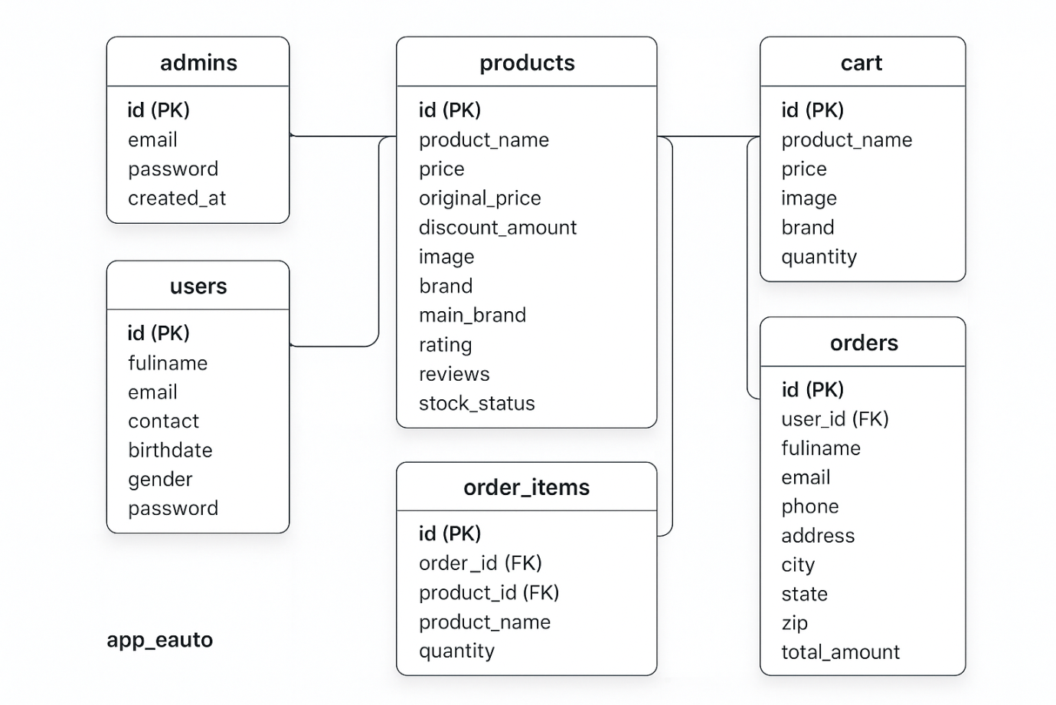

6. Data Flow Diagram (DFD)

6.1 Context Level DFD (Level 0)

Central Process
eAuto Management System

High-Level Sub-Processes
- Login & Registration – Handles Customer/Admin authentication
- Product Management – Search, browse, and manage product catalog
- Cart & Order Management – Add to cart, checkout, confirm orders
- Payment Processing – Verify and confirm transactions
- Supplier & Inventory Management – Stock updates, stock requests
- Delivery Management – Assign deliveries, track status
- Reports & Analytics – Generate sales, stock, and delivery reports for Admin

External Entities
- Customer
- Admin
- Supplier
- Delivery Staff

Data Stores
Data Store | Description
D1: User Database | Customer & admin login/registration details
D2: Product Database | Product details, categories, pricing, discounts
D3: Cart & Order Database | Cart info, order details, order history
D4: Payment/Transaction Database | Payment confirmations, transaction logs
D5: Inventory Database | Stock levels, supplier updates
D6: Delivery Database | Delivery assignments, status updates
D7: Reports Database | Aggregated data for admin reports/analytics

Data Flow (Movement)

Customer ↔ eAuto System
- Requests: Register/Login, Search Products, Add to Cart, Place Order, Payment, View Orders
- Responses: Login Confirmation, Search Results, Order Confirmation, Payment Status, Delivery Status
- Databases Accessed: D1, D2, D3, D4, D6

Admin ↔ eAuto System
- Requests: Manage Products, Orders, Users; View Reports
- Responses: Confirmation Messages, Updated Data, Reports
- Databases Accessed: D1, D2, D3, D5, D6, D7

Supplier ↔ eAuto System
- Requests: Provide Stock Info, Update Inventory
- Responses: Stock Confirmation, Order Requests
- Databases Accessed: D5

Delivery Staff ↔ eAuto System
- Requests: Delivery Assignment, Update Delivery Status
- Responses: Delivery Details, Confirmation
- Databases Accessed: D3, D6

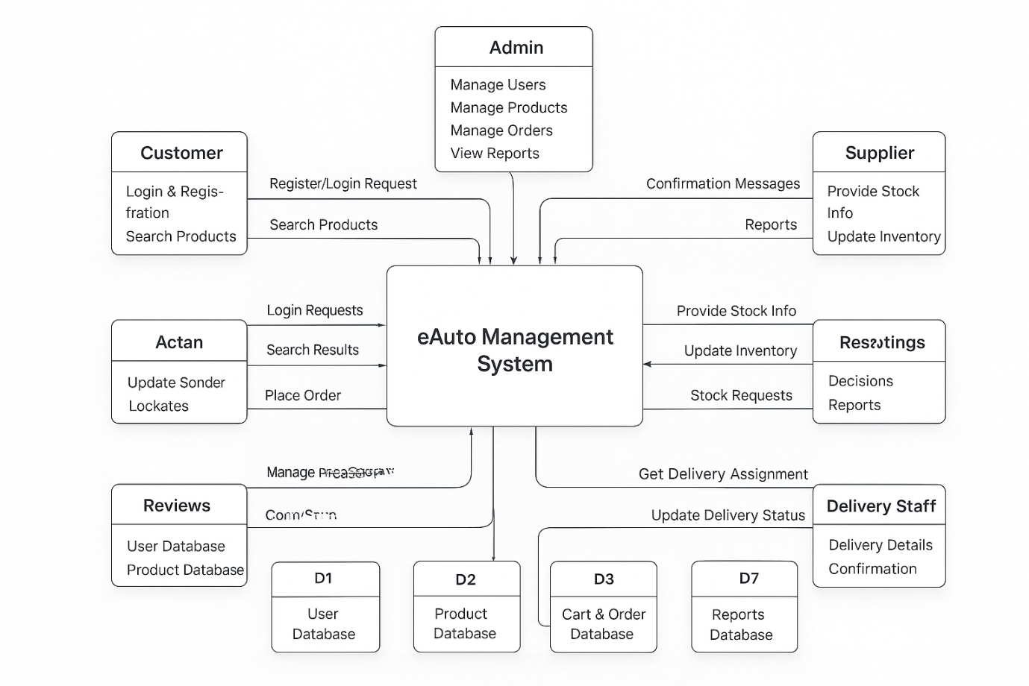

6.2 Level 1 DFD – User Processes

Processes (Inside the System)
Process | Input | Output | Data Store
1.0 Login &  Registration | Login/Register request (Customer/Admin) | Login confirmation | D1: User Database
2.0 Product  Management | Product search request (Customer), Add/Update product (Admin) | Product info / Search results | D2: Product Database
3.0 Cart & Order  Management | Add to Cart, Place Order (Customer) | Order confirmation | D3: Cart & Order Database
4.0 Payment  Processing | Payment details (Customer) | Transaction confirmation | D4: Payment Records
5.0 Supplier &  Inventory  Management | Stock info update (Supplier) | Stock confirmation | D5: Inventory Database
6.0 Delivery  Management | Delivery assignment request (System → Delivery Staff) | Delivery confirmation, Status update | D6: Delivery Records
7.0 Reports &  Analytics | Report request (Admin) | Sales / Stock / Delivery reports | D7: Reports Database

External Entities
- Customer – Register/Login, Search Products, Add to Cart, Make Payment, Track Delivery
- Admin – Manage Products, Orders, Users, Reports
- Supplier – Stock Updates, Inventory Info
- Delivery Staff – Order Delivery, Update Delivery Status

Data Stores
Data Store | Description
D1: User Database | Stores customer/admin login info
D2: Product Database | Stores product details
D3: Cart & Order Database | Stores cart & order transactions
D4: Payment Records | Stores payment details
D5: Inventory Database | Manages stock levels
D6: Delivery Records | Stores delivery status and assignments
D7: Reports Database | Stores analytics data

Data Flows
Entity | Process | Data Store
Customer ↔ 1.0 Login & Registration ↔ D1 | Authentication / Registration | User Database
Customer ↔ 2.0 Product Management ↔ D2 | Product search / browsing | Product Database
Customer ↔ 3.0 Cart & Order Management ↔ D3 | Add to cart, Place order | Cart & Order Database
Customer ↔ 4.0 Payment Processing ↔ D4 | Payment processing | Payment Records
Supplier ↔ 5.0 Supplier & Inventory Management ↔ D5 | Stock updates | Inventory Database
Delivery Staff ↔ 6.0 Delivery Management ↔ D6 | Delivery assignments / status updates | Delivery Records
Admin ↔ 7.0 Reports & Analytics ↔ D7 | Generate reports | Reports Database

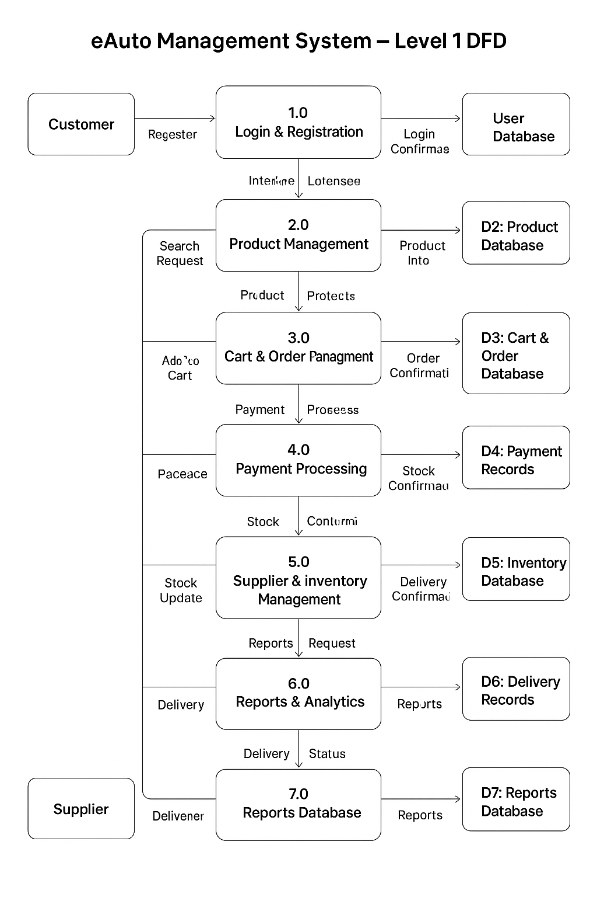
1.0 Login & Registration

External Entities
- Customer
- Admin

Data Store
- D1: User Database

Sub-Processes

1.1 Register User
- Input: Registration details (name, email, password, etc.) from Customer/Admin
- Process: Validate details, store new record
- Output: Registration confirmation
- Data Store Interaction: Insert new user into D1: User Database

1.2 Login User
- Input: Login credentials (username/email & password) from Customer/Admin
- Process: Validate credentials
- Output: Login success/failure message
- Data Store Interaction: Verify credentials from D1: User Database

Data Flows
From | To | Data
Customer/Admin → 1.1 Register User | Registration details | Input
1.1 Register User → D1: User Database | Store data | Insert
Customer/Admin → 1.2 Login User | Login credentials | Input
1.2 Login User → D1: User Database | Verify credentials | Query
1.1 Register User → Customer/Admin | Registration confirmation | Output
1.2 Login User → Customer/Admin | Login confirmation / error | Output

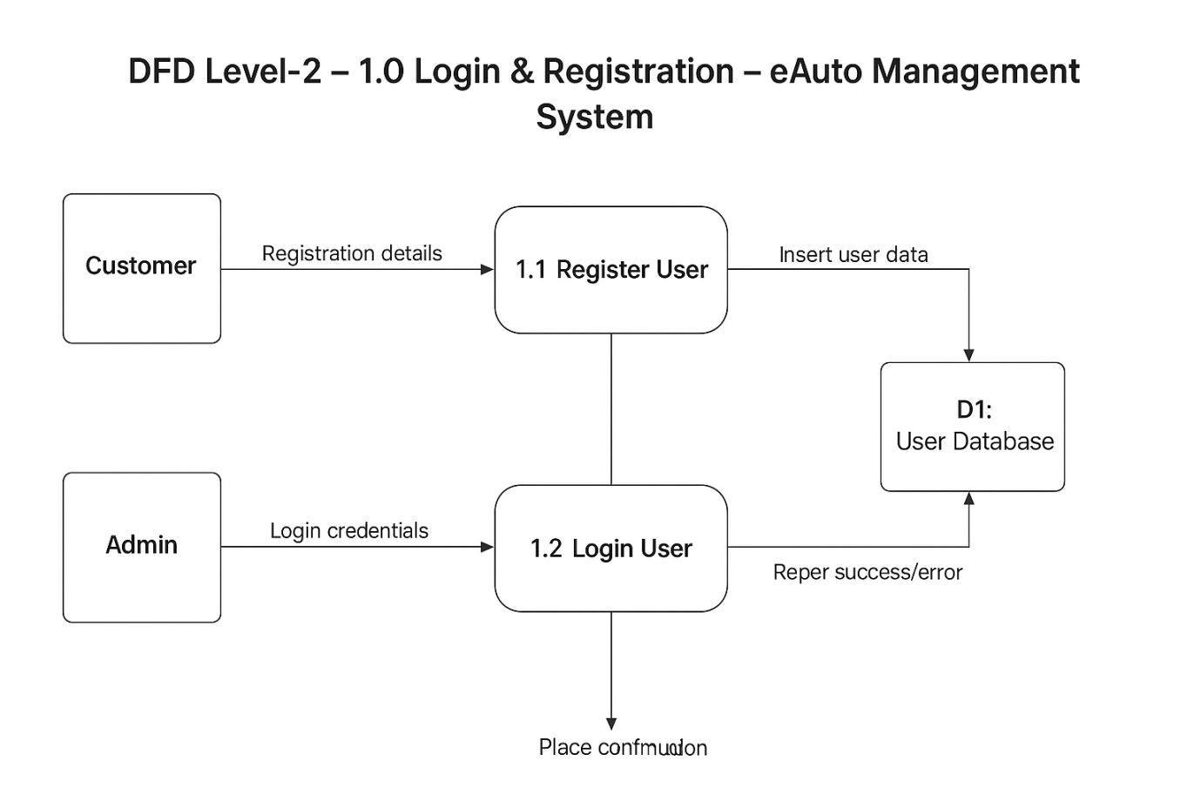

2.0 Product Management

External Entities
- Customer
- Admin

Data Store
- D2: Product Database

Sub-Processes

2.1 Search Product
- Input: Product search request from Customer
- Process: Retrieve matching product info
- Output: Search results (product list/details)
- Data Store Interaction: Read from D2: Product Database

2.2 Add Product
- Input: New product details from Admin
- Process: Validate and insert new product
- Output: Product added confirmation
- Data Store Interaction: Insert into D2: Product Database

2.3 Update Product
- Input: Updated product details from Admin
- Process: Validate and update product record
- Output: Update confirmation
- Data Store Interaction: Update record in D2: Product Database
Data Flows
From | To | Data
Customer → 2.1 Search Product | Product search request | Input
2.1 Search Product → D2: Product Database | Fetch product info | Query
D2: Product Database → 2.1 Search Product | Product details | Response
2.1 Search Product → Customer | Search results | Output
Admin → 2.2 Add Product | New product details | Input
2.2 Add Product → D2: Product Database | Insert new product | Insert
2.2 Add Product → Admin | Add confirmation | Output
Admin → 2.3 Update Product | Updated product details | Input
2.3 Update Product → D2: Product Database | Update record | Update
2.3 Update Product → Admin | Update confirmation | Output

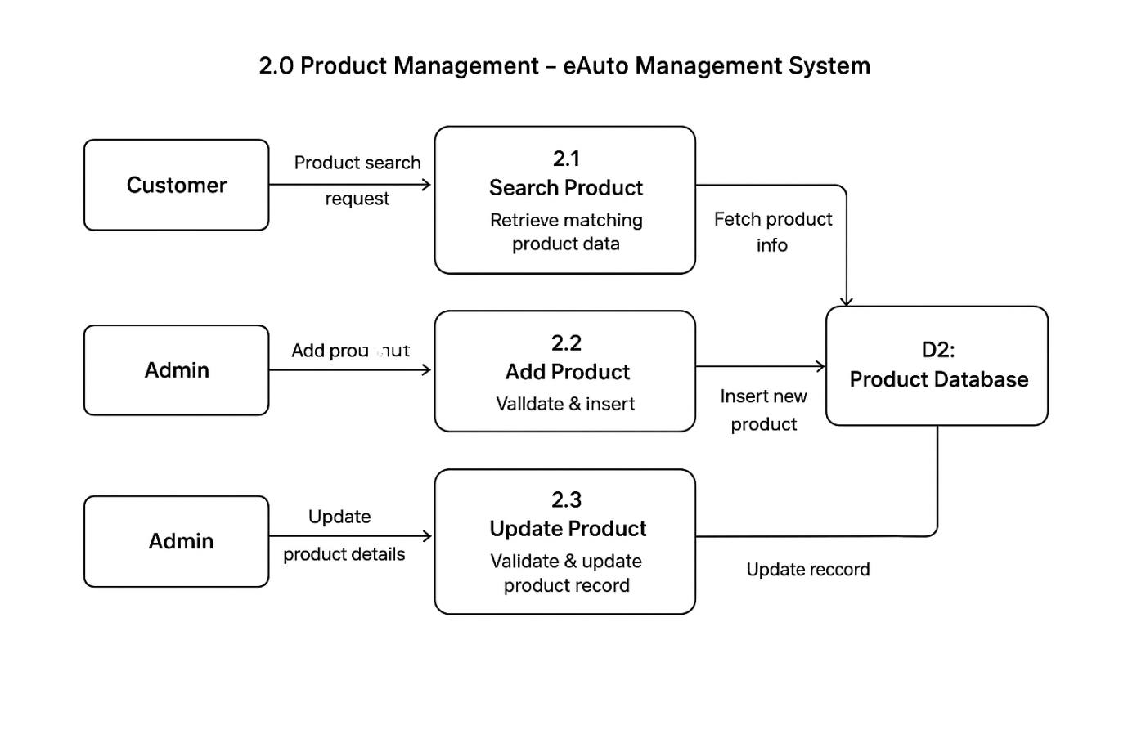

3.0 Cart & Order Management

External Entities
- Customer

Data Store
- D3: Cart & Order Database

Sub-Processes

3.1 Add to Cart
- Input: Product selection from Customer
- Process: Validate product availability and add to cart
- Output: Cart update confirmation
- Data Store Interaction: Insert/Update cart record in D3: Cart & Order Database

3.2 View Cart
- Input: Cart view request from Customer
- Process: Retrieve all items from cart
- Output: Cart details (products, quantity, total price)
- Data Store Interaction: Read from D3: Cart & Order Database

3.3 Place Order
- Input: Order request (checkout) from Customer
- Process: Validate cart items, generate order ID, store order
- Output: Order confirmation
- Data Store Interaction: Insert order details into D3: Cart & Order Database

Data Flows
From | To | Data
Customer → 3.1 Add to Cart | Product selection | Input
3.1 Add to Cart → D3: Cart & Order Database | Update cart data | Insert/Update
3.1 Add to Cart → Customer | Cart update confirmation | Output
Customer → 3.2 View Cart | Cart view request | Input
3.2 View Cart → D3: Cart & Order Database | Fetch cart items | Query
3.2 View Cart → Customer | Cart details | Output
Customer → 3.3 Place Order | Place order request | Input
3.3 Place Order → D3: Cart & Order Database | Insert order data | Insert
3.3 Place Order → Customer | Order confirmation | Output

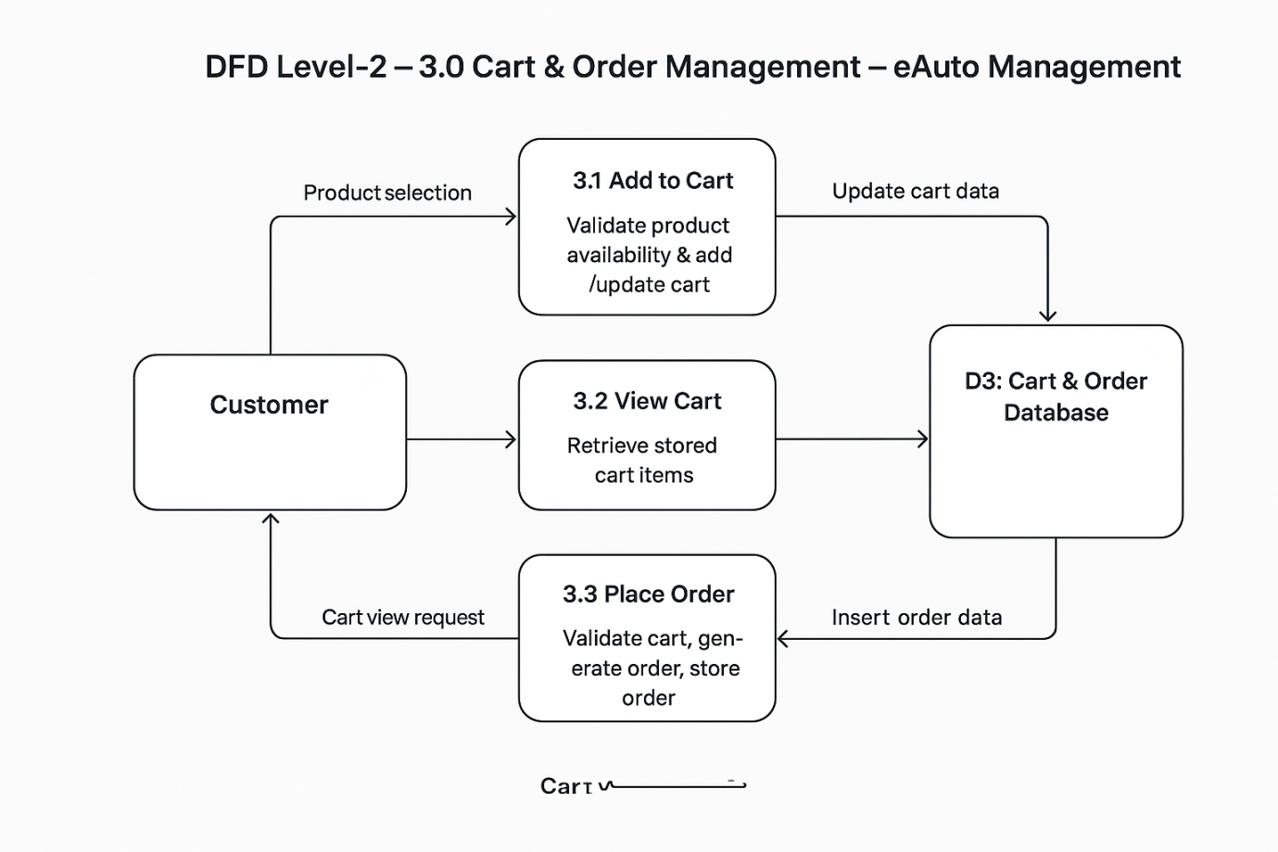

4.0 Payment Processing

External Entities
- Customer
- Bank / UPI Gateway

Data Store
- D4: Payment Records

Sub-Processes

4.1 Initiate Payment
- Input: Payment details (card/UPI/net banking/cash request) from Customer
- Process: Validate input format and forward request
- Output: Payment initiation status
- Data Flow: Send payment details to Bank/UPI Gateway

4.2 Verify Payment Details
- Input: Payment validation request from 4.1
- Process: Bank/UPI Gateway checks account/card details
- Output: Valid/Invalid response
- Data Flow: Response sent back to 4.2 Verify Payment Details

4.3 Confirm Transaction
- Input: Valid payment confirmation from Bank/UPI Gateway
- Process: Generate transaction record and store in DB
- Output: Transaction confirmation / Failure message
- Data Store Interaction: Insert into D4: Payment Records

Data Flows
From | To | Data
Customer → 4.1 Initiate Payment | Payment details | Input
4.1 Initiate Payment → Bank/UPI Gateway | Forward payment request | Request
Bank/UPI Gateway → 4.2 Verify Payment Details | Verification response | Response
4.2 Verify Payment Details → 4.3 Confirm Transaction | Validated result | Input
4.3 Confirm Transaction → D4: Payment Records | Store transaction | Insert
4.3 Confirm Transaction → Customer | Transaction confirmation | Output

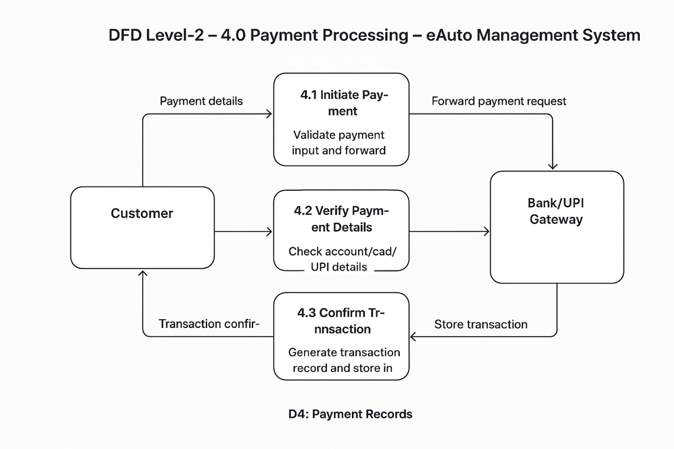

5.0 Supplier & Inventory Management

External Entities
- Supplier
- Admin

Data Store
- D5: Inventory Database

Sub-Processes

5.1 Update Stock
- Input: Stock info update from Supplier/Admin
- Process: Validate stock details and update inventory records
- Output: Stock update confirmation
- Data Store Interaction: Update D5: Inventory Database

5.2 Check Inventory
- Input: Inventory check request from Admin/System
- Process: Retrieve current stock details
- Output: Stock availability report
- Data Store Interaction: Read from D5: Inventory Database

5.3 Generate Stock Report
- Input: Report request from Admin
- Process: Compile stock levels, shortages, and supplier info
- Output: Inventory report
- Data Store Interaction: Access data from D5: Inventory Database

Data Flows
From | To | Data
Supplier/Admin → 5.1 Update Stock | Stock info update | Input
5.1 Update Stock → D5: Inventory Database | Update records | Update
5.1 Update Stock → Supplier/Admin | Stock confirmation | Output
Admin/System → 5.2 Check Inventory | Inventory check request | Input
5.2 Check Inventory → D5: Inventory Database | Retrieve stock data | Query
5.2 Check Inventory → Admin/System | Stock availability report | Output
Admin → 5.3 Generate Stock Report | Report request | Input
5.3 Generate Stock Report → D5: Inventory Database | Access data | Query
5.3 Generate Stock Report → Admin | Inventory report | Output

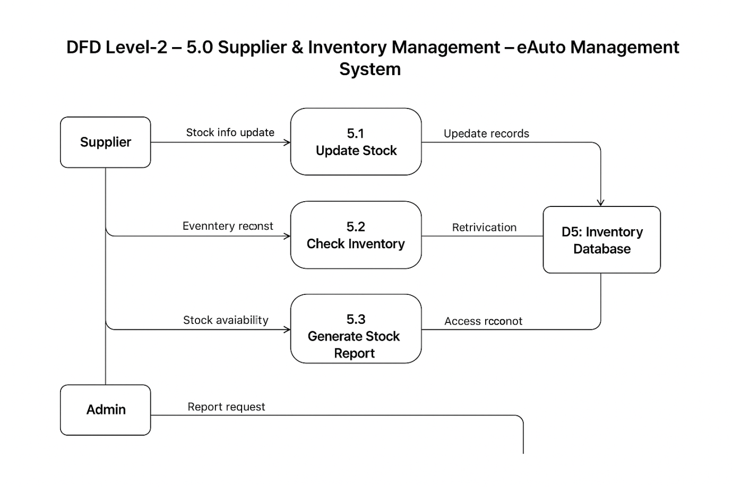

6.0 Delivery Management

External Entities
- System
- Delivery Staff
- Customer

Data Store
- D6: Delivery Records

Sub-Processes

6.1 Assign Delivery
- Input: Delivery assignment request from System
- Process: Assign order to available Delivery Staff
- Output: Delivery assignment confirmation
- Data Store Interaction: Insert assignment into D6: Delivery Records

6.2 Update Delivery Status
- Input: Delivery progress/status from Delivery Staff
- Process: Record status updates (Out for delivery, Delivered, Failed)
- Output: Updated delivery status
- Data Store Interaction: Update D6: Delivery Records

6.3 Confirm Delivery
- Input: Delivery completion info from Delivery Staff
- Process: Validate and confirm successful delivery
- Output: Delivery confirmation sent to Customer & System
- Data Store Interaction: Store confirmation in D6: Delivery Records

Data Flows
From | To | Data
System → 6.1 Assign Delivery | Delivery assignment request | Input
6.1 Assign Delivery → D6: Delivery Records | Store assignment | Insert
6.1 Assign Delivery → Delivery Staff | Assignment confirmation | Output
Delivery Staff → 6.2 Update Delivery Status | Status update | Input
6.2 Update Delivery Status → D6: Delivery Records | Update record | Update
6.2 Update Delivery Status → System/Customer | Updated status | Output
Delivery Staff → 6.3 Confirm Delivery | Delivery completion info | Input
6.3 Confirm Delivery → D6: Delivery Records | Store confirmation | Insert
6.3 Confirm Delivery → Customer | Delivery confirmation | Output
6.3 Confirm Delivery → System | Delivery confirmation | Output

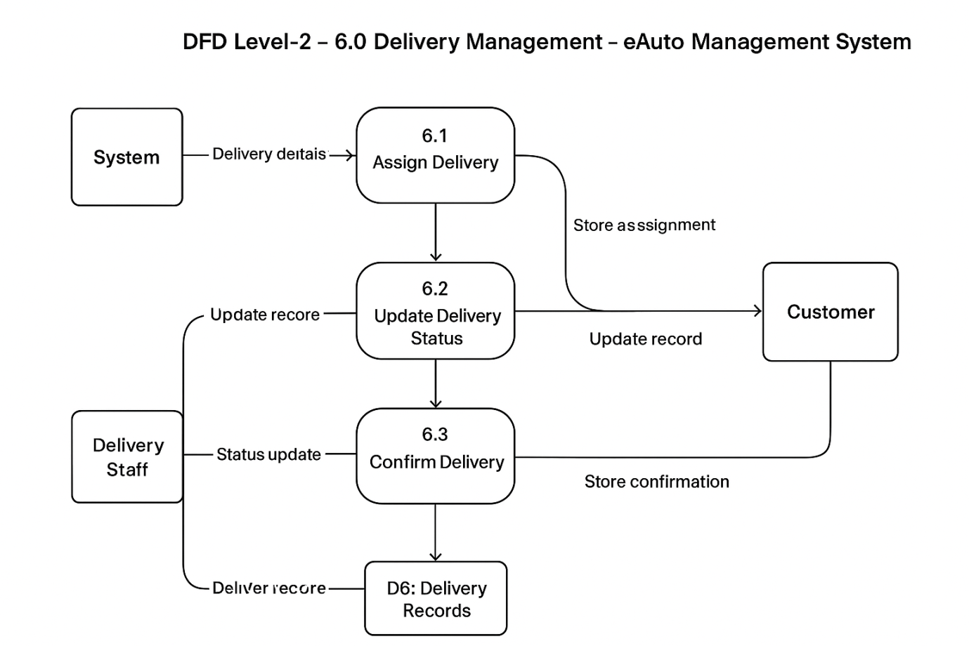

7.0 Reports & Analytics

External Entities
- Admin
- System

Data Store
- D7: Reports Database

Sub-Processes

7.1 Generate Sales Report
- Input: Report request (sales) from Admin
- Process: Compile order and payment data to generate sales insights
- Output: Sales report
- Data Store Interaction: Retrieve/store in D7: Reports Database

7.2 Generate Stock Report
- Input: Report request (stock) from Admin
- Process: Collect inventory data, show shortages and availability
- Output: Stock report
- Data Store Interaction: Retrieve/store in D7: Reports Database

7.3 Generate Delivery Report
- Input: Report request (delivery) from Admin
- Process: Summarize delivery records, delays, completion rates
- Output: Delivery report
- Data Store Interaction: Retrieve/store in D7: Reports Database

Data Flows
From | To | Data
Admin → 7.1 / 7.2 / 7.3 | Report request | Input
7.1 Generate Sales Report → D7: Reports Database | Fetch sales data | Query/Store
7.1 Generate Sales Report → Admin | Sales report | Output
7.2 Generate Stock Report → D7: Reports Database | Fetch inventory data | Query/Store
7.2 Generate Stock Report → Admin | Stock report | Output
7.3 Generate Delivery Report → D7: Reports Database | Fetch delivery data | Query/Store
7.3 Generate Delivery Report → Admin | Delivery report | Output
System → D7: Reports Database | Data sync (orders, inventory, delivery) | Update

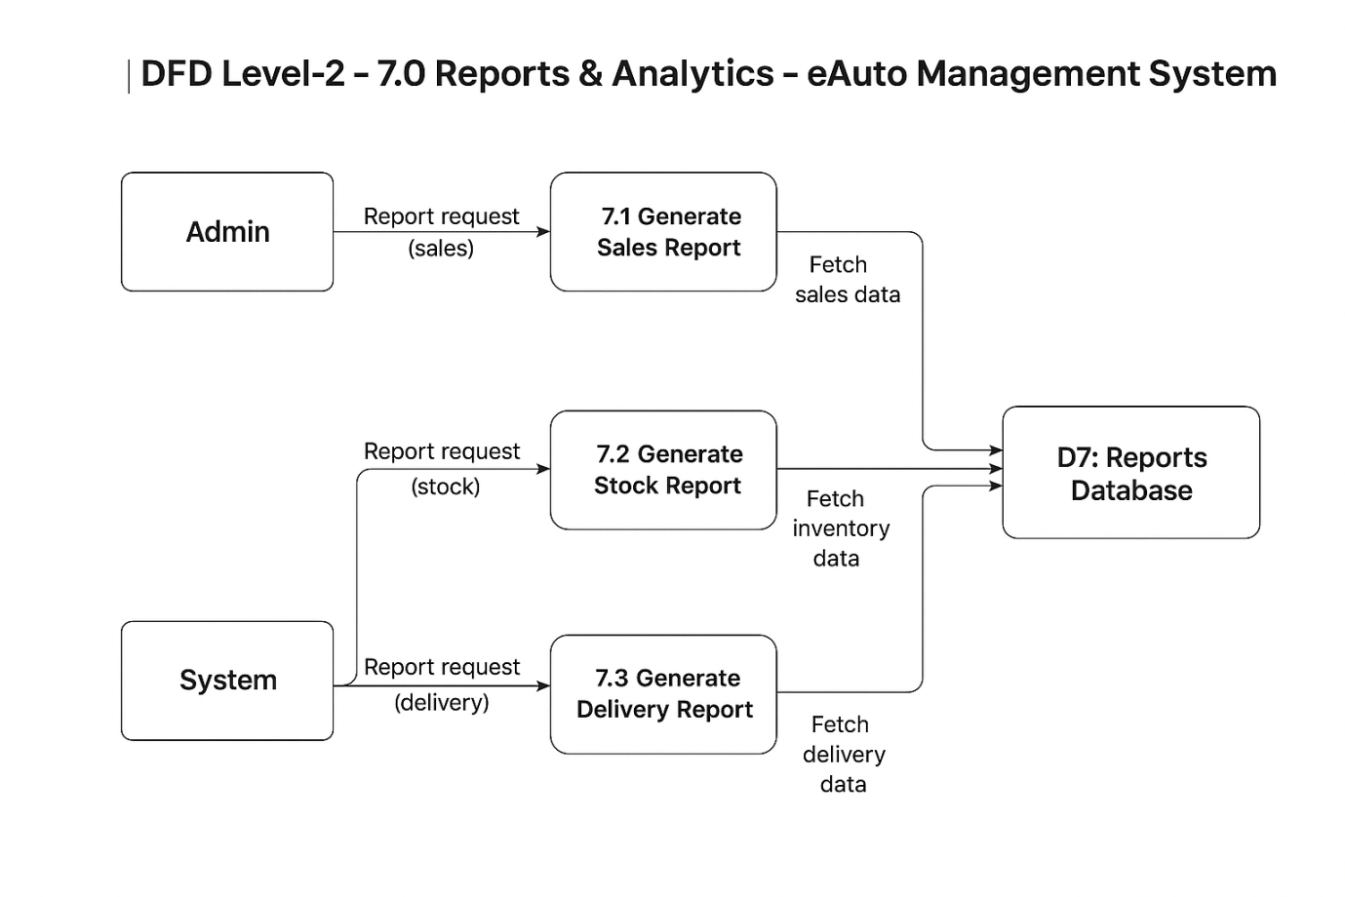

6.3 Explanation of Data Stores (MySQL)

D1: Users Table (Customers + Admins)
CREATE TABLE users (
user_id INT AUTO_INCREMENT PRIMARY KEY,
fullname VARCHAR(255) NOT NULL,
email VARCHAR(150) NOT NULL UNIQUE,
password VARCHAR(255) NOT NULL,
contact VARCHAR(20),
role ENUM('customer', 'admin') DEFAULT 'customer'
);
- Stores both customers and admins.
- role differentiates them.

D2: Products Table
CREATE TABLE products (
product_id INT AUTO_INCREMENT PRIMARY KEY,
name VARCHAR(255) NOT NULL,
brand VARCHAR(100),
category VARCHAR(100),
price DECIMAL(10,2) NOT NULL,
stock INT DEFAULT 0,
discount DECIMAL(5,2) DEFAULT 0,
description TEXT,
image_url VARCHAR(255)
);
- Product catalog with discount & stock count.

D3: Cart Table
(Each row = one product in a user’s cart)
CREATE TABLE cart (
cart_id INT AUTO_INCREMENT PRIMARY KEY,
user_id INT NOT NULL,
product_id INT NOT NULL,
quantity INT DEFAULT 1,
updated_at TIMESTAMP DEFAULT CURRENT_TIMESTAMP ON UPDATE CURRENT_TIMESTAMP,
FOREIGN KEY (user_id) REFERENCES users(user_id) ON DELETE CASCADE,
FOREIGN KEY (product_id) REFERENCES products(product_id) ON DELETE CASCADE
);
- A user can have multiple cart items.

D4: Orders Table
CREATE TABLE orders (
order_id INT AUTO_INCREMENT PRIMARY KEY,
user_id INT NOT NULL,
total_amount DECIMAL(10,2) NOT NULL,
status ENUM('Pending','Shipped','Delivered','Cancelled') DEFAULT 'Pending',
created_at TIMESTAMP DEFAULT CURRENT_TIMESTAMP,
FOREIGN KEY (user_id) REFERENCES users(user_id)
);

Order Items (child table for products inside an order)
CREATE TABLE order_items (
id INT AUTO_INCREMENT PRIMARY KEY,
order_id INT NOT NULL,
product_id INT NOT NULL,
quantity INT NOT NULL,
price DECIMAL(10,2) NOT NULL,
FOREIGN KEY (order_id) REFERENCES orders(order_id) ON DELETE CASCADE,
FOREIGN KEY (product_id) REFERENCES products(product_id)
);

D5: Payments Table
CREATE TABLE payments (
payment_id VARCHAR(50) PRIMARY KEY,
order_id INT NOT NULL,
method ENUM('UPI','Card','NetBanking','Wallet','COD') NOT NULL,
amount DECIMAL(10,2) NOT NULL,
status ENUM('Success','Failed','Pending') DEFAULT 'Pending',
transaction_date TIMESTAMP DEFAULT CURRENT_TIMESTAMP,
FOREIGN KEY (order_id) REFERENCES orders(order_id) ON DELETE CASCADE
);

D6: Delivery Records Table
CREATE TABLE deliveries (
delivery_id INT AUTO_INCREMENT PRIMARY KEY,
order_id INT NOT NULL,
delivery_staff VARCHAR(100),
delivery_address TEXT NOT NULL,
status ENUM('Assigned','Out for Delivery','Delivered') DEFAULT 'Assigned',
delivered_at TIMESTAMP NULL,
FOREIGN KEY (order_id) REFERENCES orders(order_id) ON DELETE CASCADE
);

D7: Reports Table
CREATE TABLE reports (
report_id INT AUTO_INCREMENT PRIMARY KEY,
type ENUM('Sales','Stock','Customer','Delivery') NOT NULL,
generated_at TIMESTAMP DEFAULT CURRENT_TIMESTAMP,
total_sales DECIMAL(12,2),
top_products TEXT -- Can store JSON/CSV list of product names
);

7. Flow Chart

7.1 User Registration & Login Flow
Process Steps:
- User visits the website.
- Chooses Register or Login option.
- For Registration:
  - Fill personal details (name, email, password, contact).
  - System validates details.
  - If valid → Account created → Confirmation message.
  - If invalid → Error message.
- For Login:
  - Enter email & password.
  - System checks credentials from DB.
  - If correct → User dashboard.
  - If incorrect → Error prompt.

Flow Chart Structure (Textual)
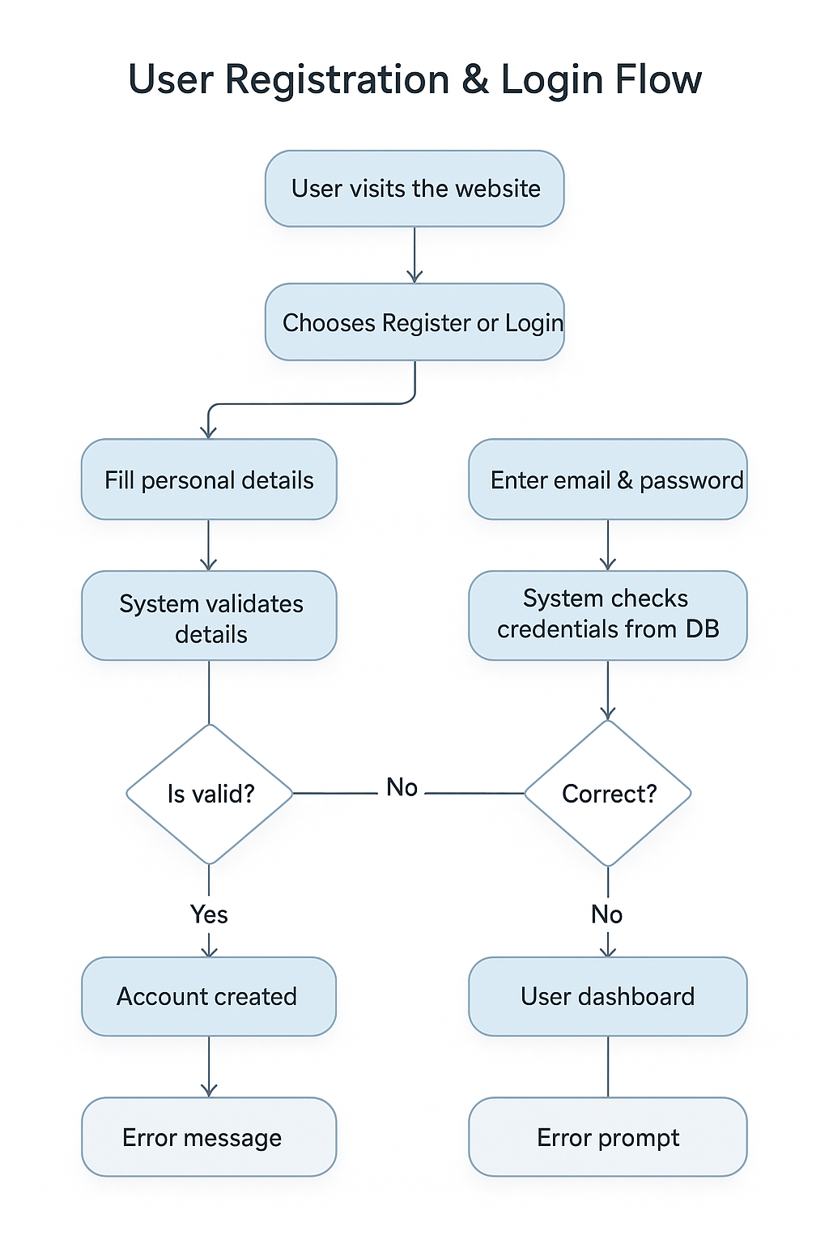

7.2 Product Purchase Flow
Process Steps:
- User browses product catalog.
- Selects a product.
- Adds product to cart.
- Proceeds to checkout.
- System verifies stock availability.
- If available → Continue.
- If not available → Show “Out of Stock.”

Flow Chart Structure (Textual):
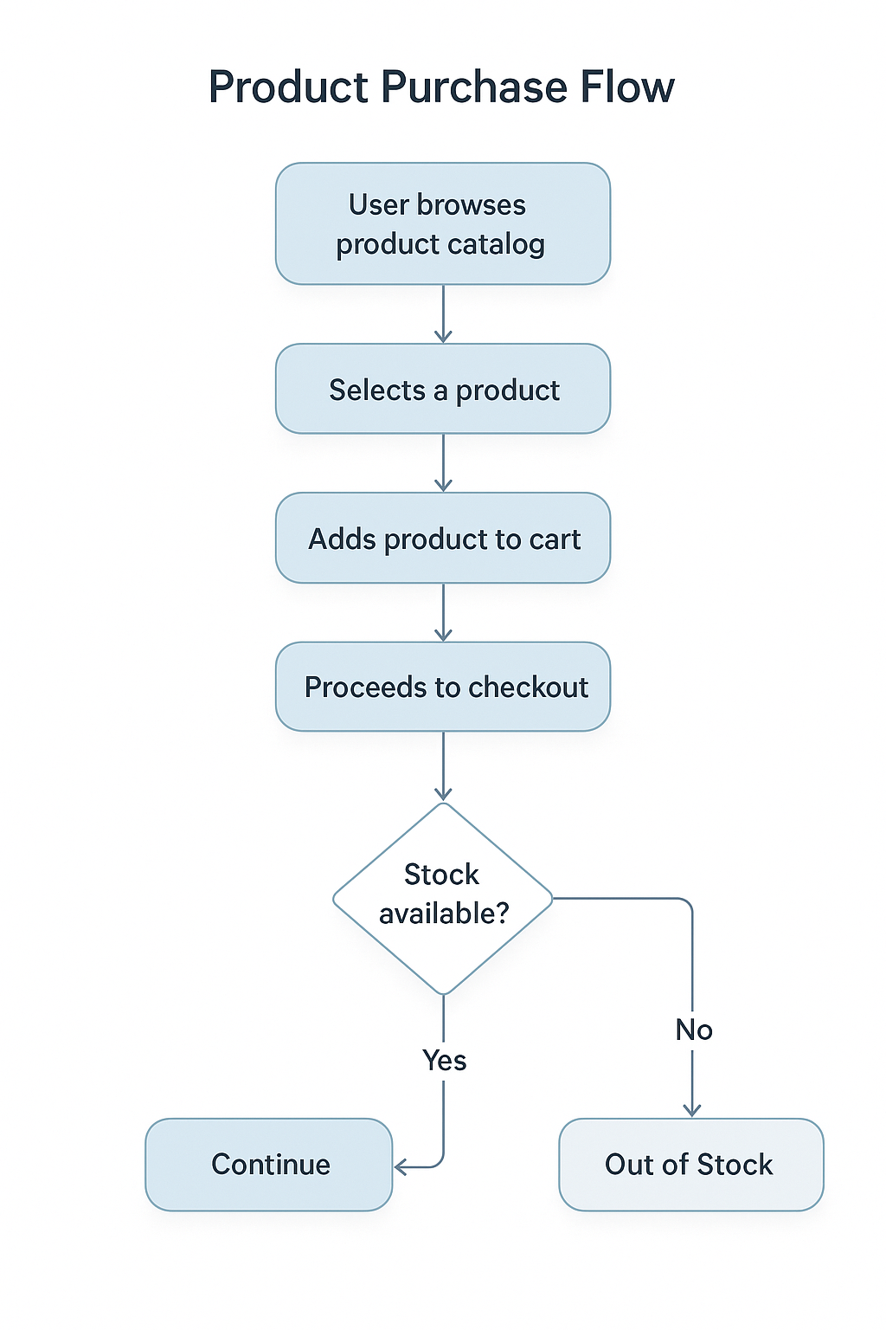

7.3 Order Management Flow
Process Steps:
- User places an order.
- Order request sent to system.
- System records order in DB.
- Order status set as Pending.
- Admin verifies and confirms order.
- If confirmed → Move to Processing.
- If cancelled → Notify user.
- Delivery staff updates status as Shipped → Delivered.

Flow Chart Structure (Textual):
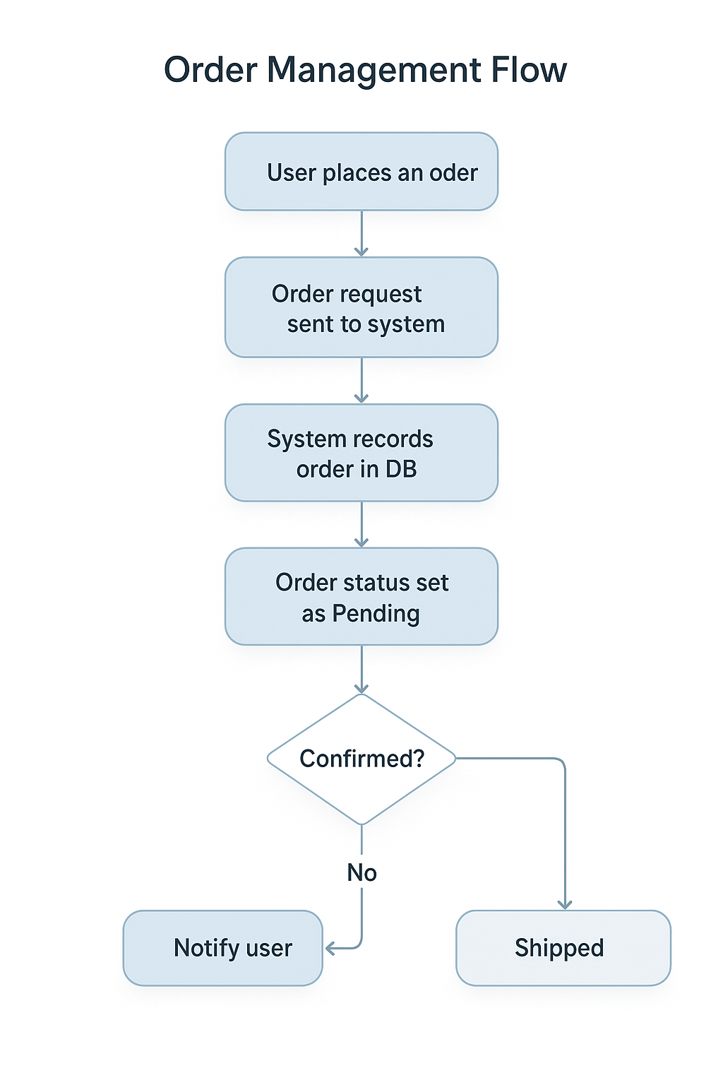

7.4 Payment Processing Flow
Process Steps:
- User proceeds to payment.
- Selects payment method (Card/UPI/NetBanking/Cash).
- System sends details to payment gateway.
- Gateway verifies payment.
- If successful → Payment Confirmation → Order Completed.
- If failed → Error Message → Retry option.

Flow Chart Structure (Textual):
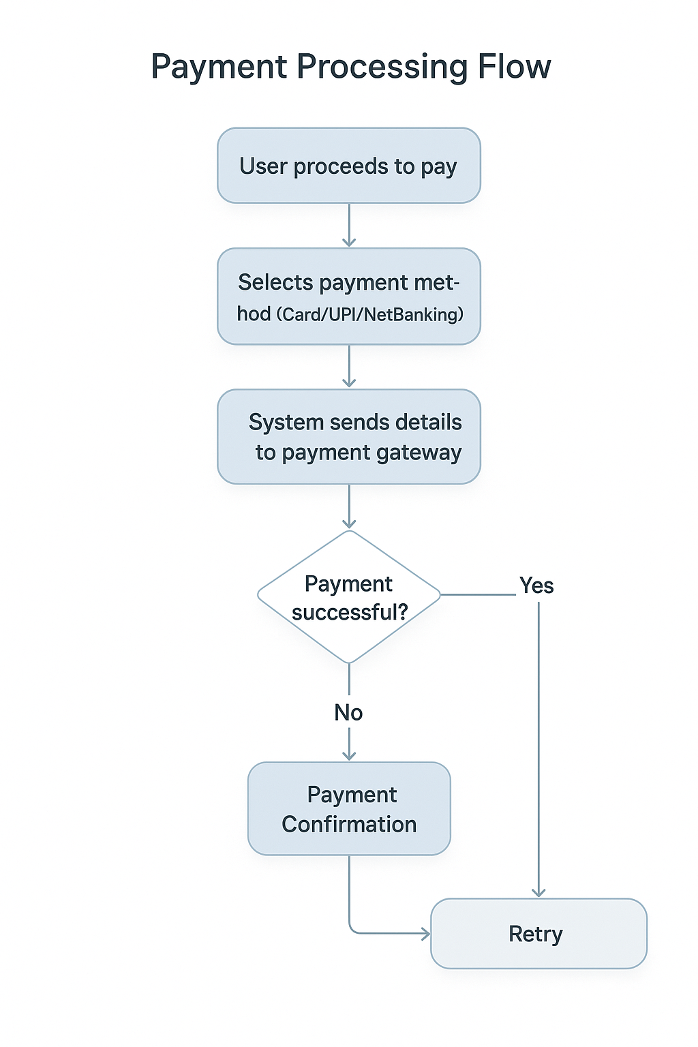

8. Implementation Details

8.1 Frontend (HTML, CSS, JavaScript, Bootstrap, AOS)
- The frontend of the system is developed using HTML, CSS, and JavaScript, ensuring a clean, structured, and user-friendly interface.
- HTML is used to design the structure of the web pages.
- CSS is applied to enhance the visual appearance, providing styling, colors, fonts, and layout management.
- JavaScript is utilized for client-side interactivity and dynamic functionalities.
- Bootstrap 5 is used for responsive layouts, grids, and pre-styled UI components like buttons, modals, and navigation.
- AOS (Animate On Scroll) library is integrated to enhance the user experience with smooth animations during scrolling.
- Major pages include:
  - Home Page → Displays featured products and categories.
  - Product Pages (Hero, Honda, Bajaj) → Brand-wise product listings.
  - Cart Page → Displays cart items dynamically.
  - Checkout Page → Checkout form with user details and payment selection.
  - Profile, Orders, Delivery Address → User account management.
- The frontend communicates with backend APIs using AJAX/Fetch (to exchange JSON data with the server).

8.2 Backend (PHP – Core PHP for Logic & Server-Side Processing)
- The backend of the system is developed using Core PHP, which handles all the server-side logic and database interactions.
- Instead of APIs, PHP pages directly communicate with the MySQL database and generate dynamic content for the frontend.
- Key functionalities implemented in PHP include:
  - User Authentication – Login and Registration modules using PHP sessions for maintaining user state.
  - Product Management – Adding, updating, deleting, and displaying products using MySQL queries.
  - Cart Operations – Adding items to the cart, updating quantities, and removing products.
  - Order Processing – Handling order placement, storing order details, and tracking status.
  - Payment Handling (Demo/Mock) – Providing options like Cash on Delivery, Card, and UPI (simulated).
  - Admin Panel – Managing products, users, and orders from the backend interface.
- PHP sessions are used for maintaining login status, cart data, and order flow across different pages.
- All database operations are handled via MySQLi queries for secure and efficient interaction.

8.3 Database (MySQL – Tables & Schema)
- The project uses MySQL as the backend relational database management system (RDBMS).
- phpMyAdmin or MySQL CLI is used to manage the database.
- The schema is designed using multiple interrelated tables with primary keys, foreign keys, and relationships to ensure data integrity.
- Main Tables in the Database:
  - Users → Stores user details (user_id, fullname, email, contact, birthdate, gender, password).
  - Admins → Stores administrator login details (admin_id, email, password, created_at).
  - Products → Contains product information (product_id, name, brand, category, price, stock, discount, image, status).
  - Cart → Maintains user’s selected items (cart_id, user_id, product_id, quantity).
  - Orders → Stores confirmed orders (order_id, user_id, customer details, shipping address, total_amount, payment_method, created_at).
  - Order_Items → Stores products inside each order (order_item_id, order_id, product_id, product_name, quantity, price).
  - Payments → Stores transaction details (payment_id, order_id, method, amount, status, transaction_date).
  - DeliveryRecords → Tracks delivery (delivery_id, order_id, staff_name, delivery_address, status, delivered_at).
  - Reports → Admin analytics reports (report_id, type, generated_at, data).
- Database Design Features:
  - Proper use of Primary Keys for unique identification.
  - Foreign Keys to establish relationships (e.g., order_items linked to orders and products).
  - Use of constraints like NOT NULL, UNIQUE, and AUTO_INCREMENT for data consistency.
  - Normalization applied to reduce redundancy and improve query efficiency.

8.4 Security Features (Authentication, Session Management, Validation)
- Authentication
  - Secure login using hashed passwords (bcrypt/MD5).
  - Session tokens issued on successful login.
- Session Management
  - PHP sessions maintain user state across requests.
  - Token-based authentication for React frontend API calls.
- Validation
  - Client-side (React) form validation for inputs.
  - Server-side (PHP) validation for email, password, and payment details.
- Data Security
  - Passwords stored in encrypted format.
  - APIs restricted with role-based access (User/Admin).
- Other Features
  - Prevention of SQL Injection (Prepared Statements).
  - Prevention of Cross-Site Scripting (XSS) using input sanitization.

9. Testing

9.1 Test Cases (Unit & Integration)
Test  Case  ID | Module | Test  Scenario | Input | Expected  Output | Result
TC-01 | Login & Registration | User enters valid credentials | Email: user@test.com, Password: 1234 | Redirect to dashboard/homepage | Pass
TC-02 | Login & Registration | User enters invalid credentials | Email: wrong@test.com, Password: xyz | Show error message “Invalid credentials” | Pass
TC-03 | Cart Management | Add product to cart | Product ID: 101, Qty: 2 | Cart updated with correct product & quantity | Pass
TC-04 | Cart Management | Remove product from cart | Remove Product ID: 101 | Cart updated with product removed | Pass
TC-05 | Order Placement | Place order with valid cart items | Cart → Checkout → Confirm | Order ID generated, status = “Pending” | Pass
TC-06 | Payment Processing | Valid payment via UPI/Card | Payment details entered | Payment Success message, status = “Paid” | Pass
TC-07 | Payment Processing | Invalid payment details | Wrong Card Number | Show error message “Transaction Failed” | Pass
TC-08 | Admin Management | Add new product | Product details form | Product stored in DB & visible in product list | Pass
TC-09 | Admin Management | Generate Sales Report | Click “Generate Report” | Report file created with correct data | Pass

9.2 User Testing (UI/UX & Functional)
User testing was carried out with a group of 10 students and faculty members. The testing focused on UI clarity, navigation, responsiveness, and functional workflows.
- ✅ Login/Register: Smooth and easy to use.
- ✅ Product Browsing: Search and filter features worked correctly.
- ✅ Cart & Checkout: Easy navigation from cart to payment.
- ✅ Responsiveness: Website adapted well to desktop and mobile screens.
- ✅ Animations (AOS): Added better user experience without slowing down performance.
Feedback:
- Minor improvements suggested in search filtering speed and dark mode option.

9.3 Admin Testing
Admin panel functionalities were tested for CRUD operations, report generation, and order management.
- ✅ Admin successfully added, updated, and deleted products.
- ✅ Order management system allowed status update
(Pending → Shipped → Delivered).
- ✅ Sales & Inventory Reports generated correctly.
- ✅ User management (block/unblock) worked as expected.

9.4 Performance & Load Testing
Performance testing was performed using JMeter & manual load simulation.
Test Type | Scenario | Result
Page Load Speed | Homepage load under 2 seconds | ✅ Passed
Concurrent Users | 50 users browsing simultaneously | ✅ Passed
Order Placement Stress | 20 users placing order at same time | ✅ Passed
Database Query Speed | Fetching 1000+ products with filters | ✅ < 1.5s
Payment Gateway Response | Average response time < 3s | ✅ Passed

10. Limitations of the Project

10.1 Technical Limitations
- The system is developed using Core PHP and MySQL, which may limit scalability when handling a very large number of concurrent users compared to modern frameworks.
- Complex queries in MySQL involving large datasets may affect performance if proper indexing and optimization are not applied.
- Security measures such as advanced encryption, prepared statements for all queries, and modern authentication mechanisms (e.g., OAuth2.0, multi-factor authentication) are not fully implemented, which may limit robustness.
- The system currently relies on a local server/XAMPP setup during development, which restricts scalability, performance, and availability compared to cloud-based deployment.

10.2 Functional Limitations
- Payment methods are limited to basic transactions (Cash, UPI, Net Banking, Debit/Credit Card) and do not yet support wallets, EMI, or international gateways.
- The delivery management system is simplified and lacks real-time tracking or integration with third-party logistics providers.
- Reporting and analytics features are basic and do not provide deep insights or predictive analytics for sales, user behavior, or inventory trends.
- No dedicated mobile app is currently available, restricting accessibility to desktop and web browsers only.
10.3 Future Enhancements
To overcome the above limitations and improve the system, the following enhancements can be considered in future iterations:
- Develop a mobile application (Android & iOS) for wider accessibility.
- Implement AI-driven product recommendations based on user behavior and purchase history.
- Introduce advanced reporting and dashboards for admins, including sales forecasting, inventory optimization, and customer insights.
- Enable integration with third-party delivery services (e.g., Delhivery, Shiprocket) to provide real-time tracking.
- Expand payment gateway support to include PayPal, Razorpay, wallets, and international payment methods.
- Deploy the system on cloud platforms (AWS, Azure, or GCP) for better scalability, security, and performance.

11. Conclusion

11.1 Summary of Work
The project “eAuto – Bike Spare Parts E-Commerce Platform” was designed and developed to provide a seamless digital marketplace for two-wheeler spare parts.
The system integrates:
- Frontend: HTML, CSS, JavaScript, Bootstrap, and AOS for a responsive and interactive user interface.
- Backend: Core PHP for server-side logic and business processing.
- Database: MySQL for handling product, user, order, and transaction records.
The platform supports user registration, login, product browsing, cart management, order placement, and payment processing, along with admin functionalities such as managing products, users, inventory, orders, and reports.
This project successfully bridges the gap between suppliers, customers, and delivery systems, offering a reliable solution for bike spare parts e-commerce.

11.2 Achievements
- Developed a fully functional e-commerce system with user-side and admin-side modules.
- Implemented secure authentication and session management for protecting user accounts.
- Integrated cart, checkout, and order management workflows in real-time.
- Designed a MongoDB database schema to handle collections such as users, products, orders, payments, and deliveries.
- Provided basic reporting and analytics for admins to monitor sales, inventory, and performance.
- Delivered a responsive and user-friendly interface with animations for better UX.

11.3 Future Scope
The project lays the foundation for a scalable and advanced platform. In the future, it can be enhanced with:
- Mobile applications (Android/iOS) for better accessibility.
- AI-driven product recommendations to personalize the shopping experience.
- Advanced reporting & dashboards with predictive analytics for business intelligence.
- Integration with third-party delivery partners for real-time shipment tracking.
- Expanded payment options, including PayPal, wallets, EMI, and international gateways.
- Cloud deployment (AWS, Azure, GCP) for improved scalability, performance, and global reach.

12. References

- React JS Documentation – https://react.dev
- Bootstrap 5 Documentation – https://getbootstrap.com
- MongoDB Documentation – https://www.mongodb.com/docs
- PHP Official Documentation – https://www.php.net/docs.php
- MDN Web Docs (HTML, CSS, JavaScript) – https://developer.mozilla.org
- W3Schools Tutorials – https://www.w3schools.com
- GeeksforGeeks (Web Development & Database Concepts) – https://www.geeksforgeeks.org
- TutorialsPoint – https://www.tutorialspoint.com
- Stack Overflow – https://stackoverflow.com (for troubleshooting and coding references)
- Research papers and articles on E-Commerce Platforms, Payment Systems, and Inventory Management accessed via Google Scholar.

